Project Report: “Empty File Finder”
Subject: Operating Systems
Submitted By:
Atika Mughal (5000000280),
Ayesha Daudpota (5000000274),
Mohammad Ammar Hussain (5000000278),
Ghulam Fatima (5000000277)
Dept: BS-AI (B) – F24
Submitted to:
Sir Bilal Ahmed
1. INTRODUCTION
The Empty File Finder is a command-line utility developed in C programming language that runs on Ubuntu Linux. It recursively scans a given directory and finds all files whose size is zero bytes (empty files).
Empty files are created due to:
- Incomplete file downloads
- Failed write operations
- Temporary placeholder files
- Build system artifacts
This project demonstrates the use of Operating System concepts like system calls, file system traversal, and POSIX standards in a real-world C program.
2. OBJECTIVES
The main objectives of this project are:
- To recursively traverse a directory tree using POSIX opendir() and readdir() functions.
- To retrieve file metadata using stat() system call.
- To identify all regular files with size = 0 bytes.
- To support command-line options:
- -v Verbose mode
- -d Delete mode
- -n No colour output
- -h Help screen
- To handle errors like permission denied, broken symbolic links, and deeply nested directories.
- To display a summary of total files scanned and empty files found.
3. TOOLS AND REQUIREMENTS
Hardware Requirements:
- Any PC or Laptop
- Minimum 1GB RAM
- Minimum 10GB Storage
Software Requirements:
- Operating System : Ubuntu Linux (22.04 LTS)
- Virtual Machine : VirtualBox
- - Language : C Programming
- - Compiler : GCC (GNU Compiler Collection)
- - Text Editor : Nano / Gedit
- - Standard : POSIX / C11
Commands Used to Install Tools:
- sudo apt update
- sudo apt install gcc make -y
4. OPERATING SYSTEM CONCEPTS USED
Concept | Description
opendir() | Opens a directory stream for reading
readdir() | Reads entries from directory one by one
closedir() | Closes the directory stream
stat() / lstat() | Gets file metadata (size, type, perms)
S_ISREG() | Checks if entry is a r egular file
S_ISDIR() | Checks if entry is a directory
unlink() | Deletes a file from filesystem
errno / perror() | POSIX error handling
getopt() | Parses command-line arguments
Recursion | Traverses subdirectories automatically

5. PROJECT STRUCTURE
Empty_File_Finder/
├── src/
│ └── empty_finder.c ← Main C source code
├── Makefile ← Build rules
├── run_project.sh ← Demo shell script
└── test_dir/ ← Test directory
├── empty1.txt (0 bytes - empty)
├── empty2.c (0 bytes - empty)
├── has_content.txt (has data)
└── subdir1/
├── empty3.log (0 bytes - empty)
├── also_content.py
└── subdir2/
├── deep_empty.txt (0 bytes - empty)
└── deep_content.dat (has data)
Total Files: 7
Empty Files: 4
Screenshot 1: Compiling the program
Screenshot 2: Creating test directory
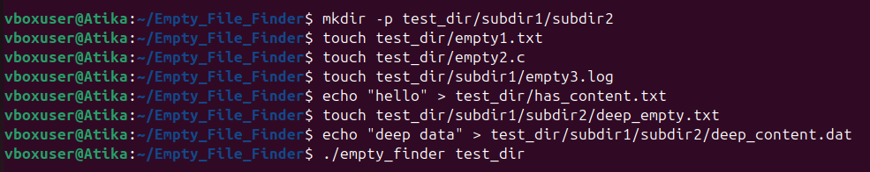
Screenshot 3: Running basic scan
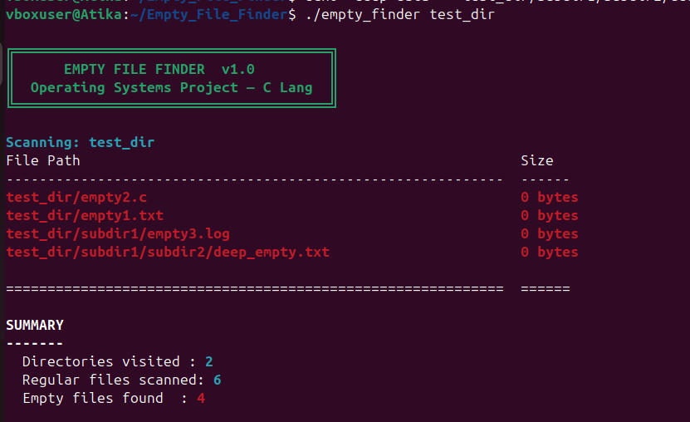
Screenshot 4: Running verbose mode
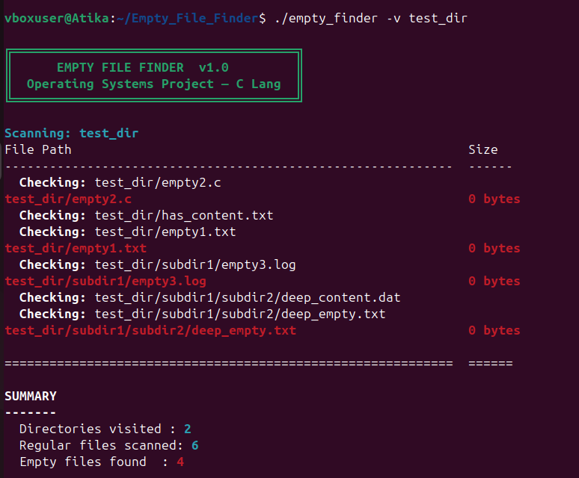

Screenshot 5: Running help screen
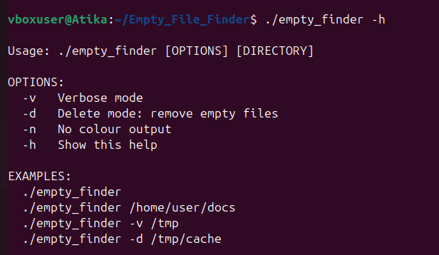
Screenshot 6: Your actual output
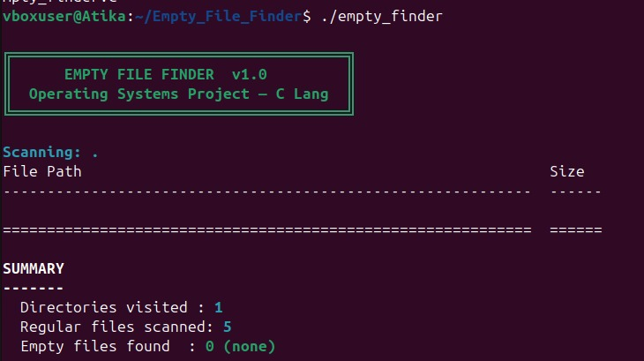
8. OUTPUT EXPLANATION
The program produces the following output sections:
1. BANNER (Green Color)
- Shows project name and version
- Confirms program started successfully
2. SCANNING LINE (Cyan Color)
- Shows which directory is being scanned
3. FILE LIST (Red Color)
- Shows full path of every empty file found
- Red color highlights the problem files
4. SUMMARY SECTION
- Directories visited : how many folders scanned
- Regular files scanned : total files checked
- Empty files found : total 0-byte files found
(shown in Red if > 0, Green if = 0)
Exit Code:
- Returns 0 if no empty files found
- Returns 1 if empty files were found
9. CONCLUSION
The Empty File Finder project was successfully developed and tested on Ubuntu Linux using C programming language. Key achievements: - Successfully implemented recursive directory traversal - Used stat() system call to read file metadata - Handled errors using POSIX errno standards - Supported multiple command-line flags - Displayed color-coded output using ANSI codes. The program works correctly on Ubuntu and can be used as a real system administration utility.

